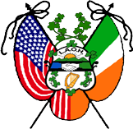 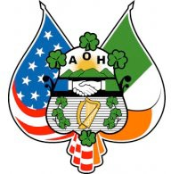

ANCIENT ORDER OF HIBERNIANS MONSIGNOR SLOCUM DIVISION #1 LADIES ANCIENT ORDER OF HIBERNIANS DIVISION #66

WATERBURY, CT

2025 BIENNIAL STATE CONVENTION CONVENTION PUB NIGHT RESERVATION

**Friday October 3,2025**

**AOH Collins Hall**

**91 Golden Hill St. Waterbury, CT 06706**

**5:00 PM - 11PM**

**Cash Bar**

**A Ziti Dinner with Tossed Salad, Rolls and Coffee will be served.**

**On this evening The Monsignor Slocum Division will be presenting AOH Veterans Pins to our Division members. Please join us for this special ceremony honoring our Hibernian Veterans**

**Live Irish Entertainment in the Bar provided by Jeff Blaney**

**Name:**

**Division: No. of Tickets @ $20.00 EA**

RESERVATION FORM WITH CHECK

MADE PAYABLE TO: “Friends of the Hibernians” Memo line: *Convention Pub Night*

SHOULD BE RETURNED NO LATER THAN September 15,2025 *

**TO: AOH c/o Art Lanese**

**91 Golden Hill St. Waterbury, CT 06706**

*Ticket Price is $25.00 after September 15