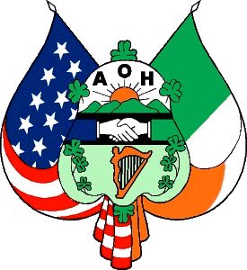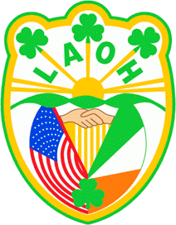**ANCIENT ORDER OF HIBERNIANS MONSIGNOR SLOCUM DIVISION #1**

**LADIES ANCIENT ORDER OF HIBERNIANS DIVISION #66 WATERBURY, CT**

2025 BIENNIAL STATE CONVENTION CONVENTION BANQUET RESERVATION

Saturday Evening October 4, 2025

**AOH Collins Hall 91 Golden Hill St. Waterbury, CT 06706**

Cocktail Hour: 5:30 PM - Cash Bar Dinner 7:00 PM

**Entertainment by:**

**SECOND CHANCE ACOUSTICS**

**AND**

**ANGELS OF HAMONY**

**Name:**

**Division: No. of Tickets @ $ 45.00 EA\***

**Buffet Featuring Stuffed Sole, Chicken Marsala or Francaise, Baked Sliced Ham, Roast Pork, Veal and Peppers, Roast beef, Pasta and Sauce, Tossed Salad, Roast Potatoes, Green Beans, Bread and Butter and Coffee**

**RESERVATION FORM WITH CHECK MADE PAYABLE TO: “FRIENDS OF THE HIBERNIANS”**

**MEMO: *Convention***

**TO BE RETURNED NO LATER THAN September 15,2025* TO: AOH c/o ART LANESE**

**91 GOLDEN HILL ST. WATERBURY, CT 06706**

**\*Dinner price is $50 after September 15**